2) Ubuntu Instance:

1. Ubuntu Launch Instance:

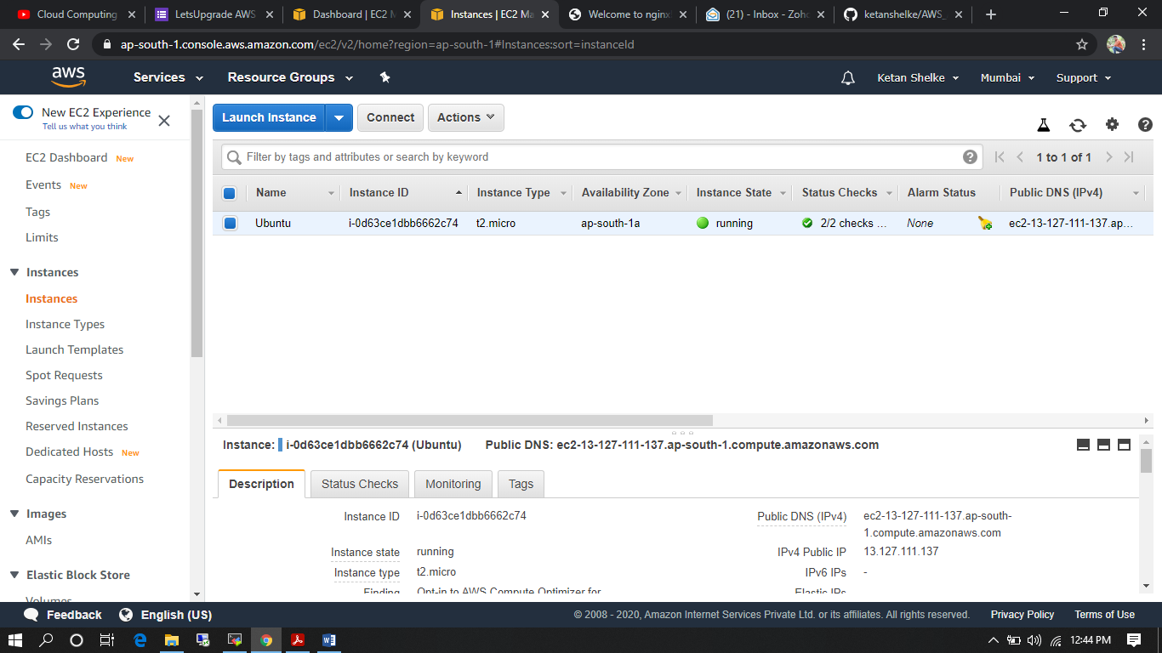

1. Nginx installation in MobaXterm:

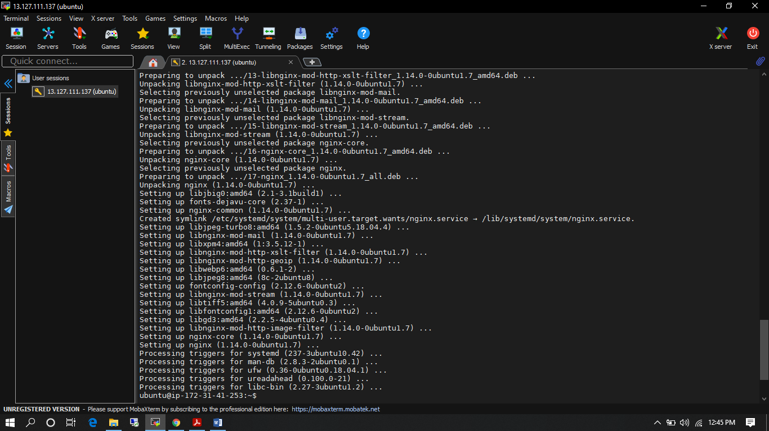

1. Nginx on Ubuntu Instance(13.127.111.137):

